XXCTS_INVENTORY_JUNE

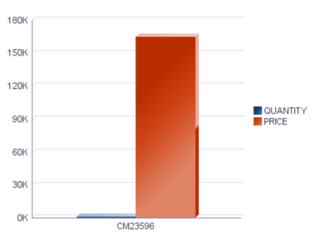
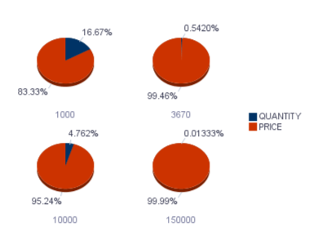

XXCTS_INVENTORY_JUNE

Inventory Item Id | Organization Id | Segment1 | Description | Purchasing Enabled Flag | Quantity | Price | Total
FOR LOOP  INVENTORY_ITEM_ID | ORGANIZATION_ID | SEGMENT1 | DESCRIPTION | PURCHASING_ENABLED_FLAG | QUANTITY | PRICE | TOTAL END LOOP

